**Basic Linux commands PART 1**

***Check Free CPU memory***

Free; This shows the used, total and free memory.

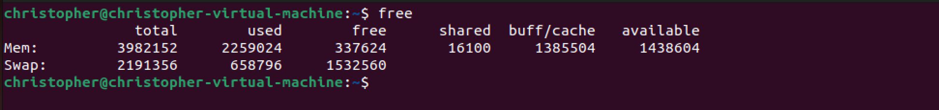

***Check current processes***

Ps; shows a snapshot of current processes.

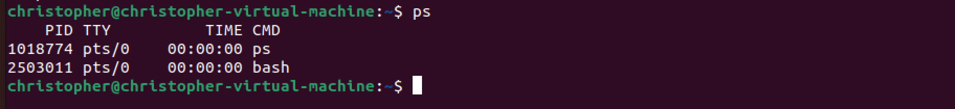

***Check active Linux processes***

top; displays current Linux processes.

htop: gives graphical representation.

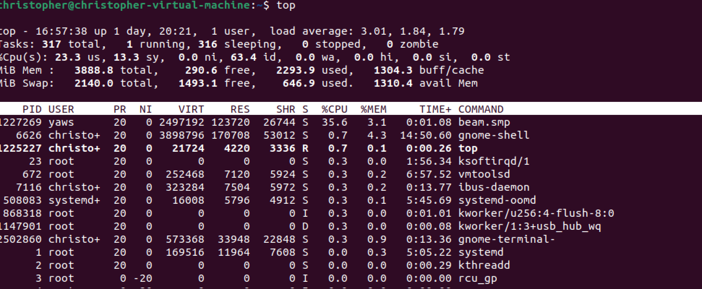

***IP traffic monitor***

Iptraf; shows a GUI page for ethernet traffic



Iptraf -ng nc; captures traffic

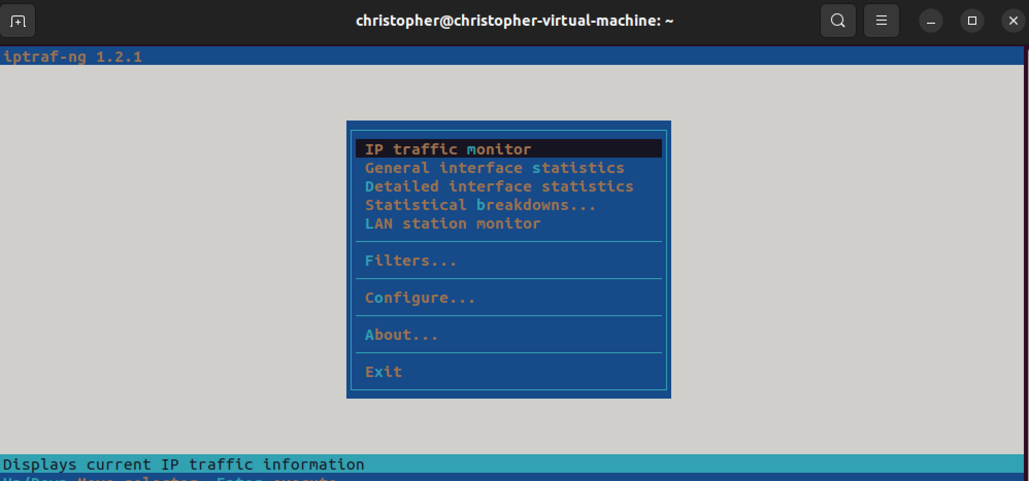

***Controlling Network manager***

Nmcli; shows all network interface

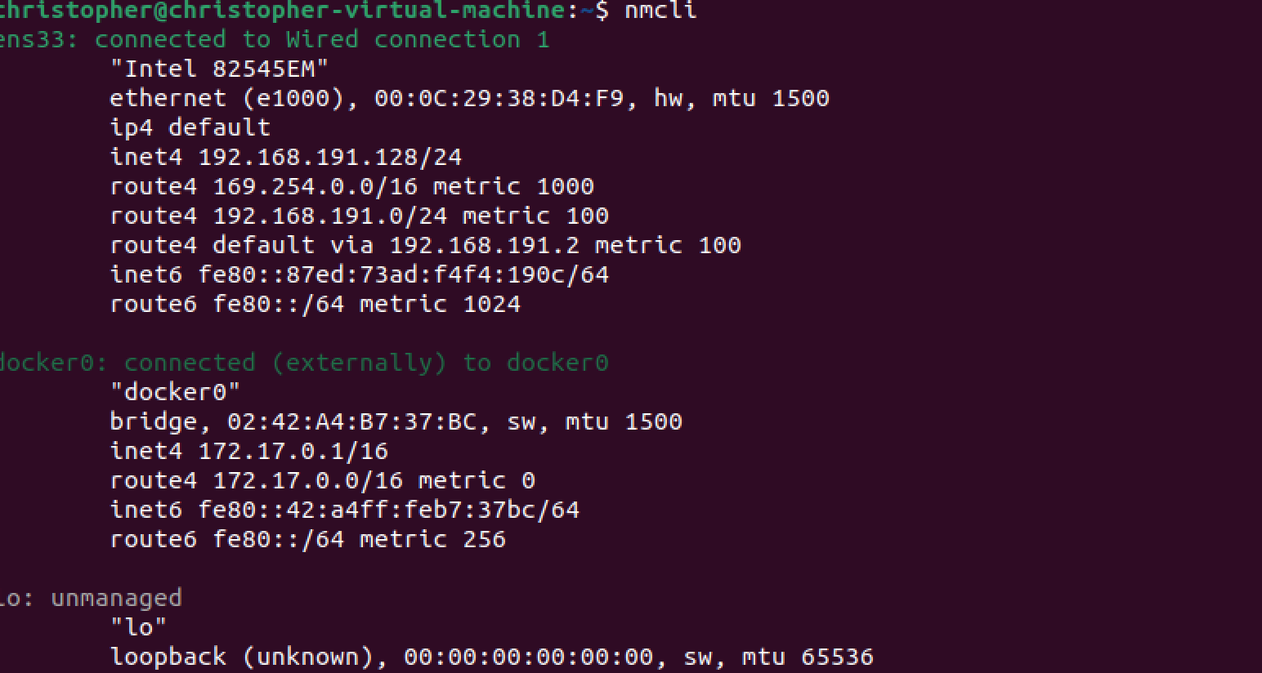

***List files and directories***

ls; list all files and directories

ls -a; list all hidden files

ls-al;

ls -ah;

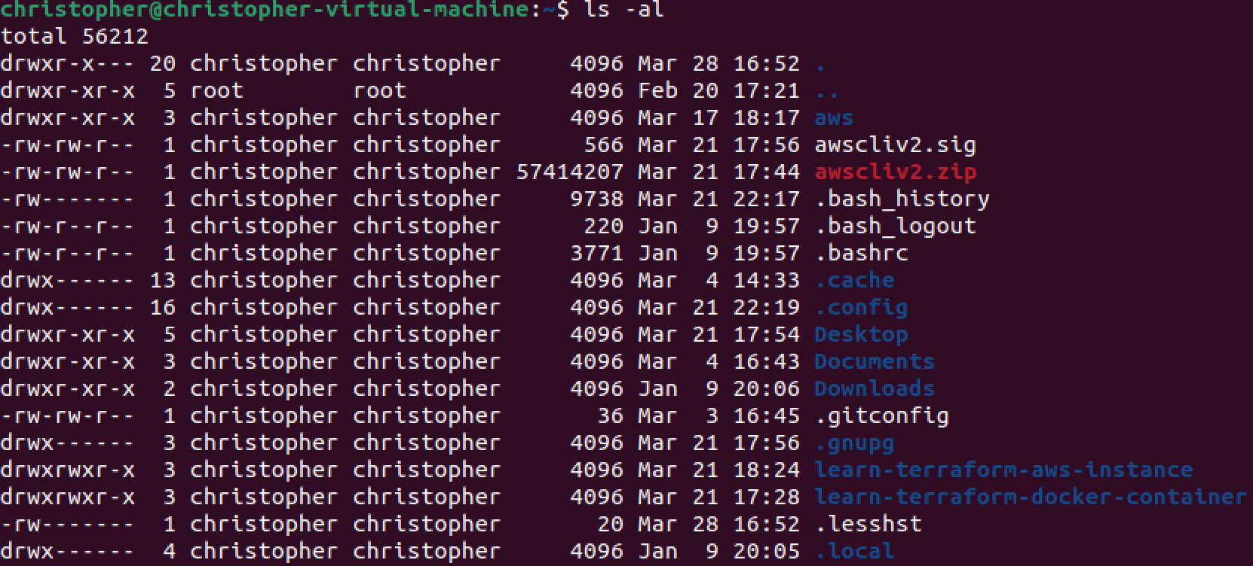

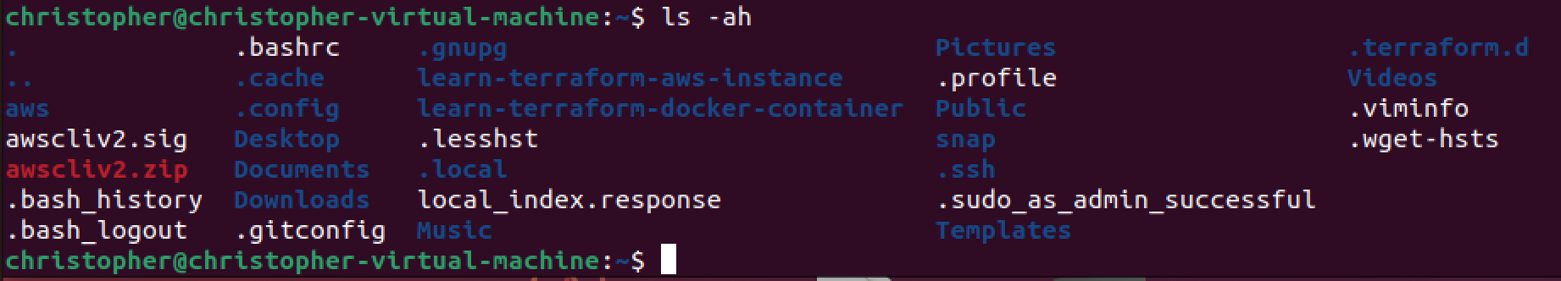

***Controls the hostname***

hostnamectl; displays all info on controlling the hostname

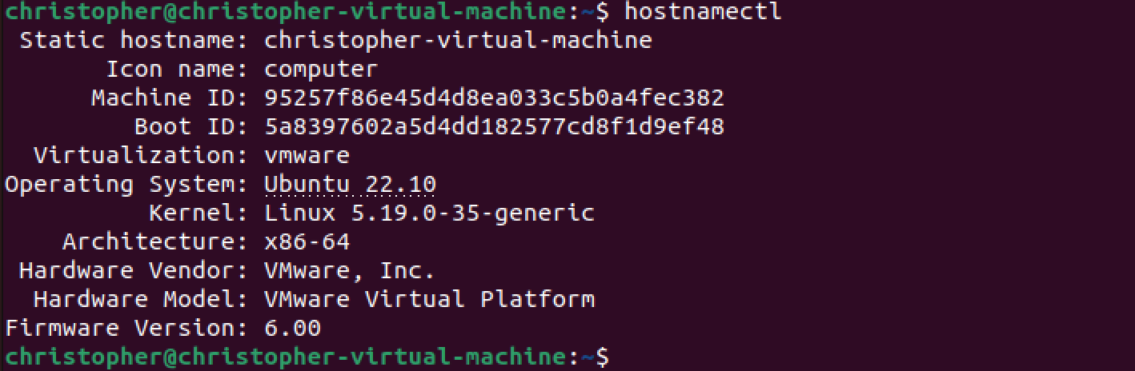

***Netstat***

***Check listening ports***

netstat -tulpn; shows all active ports on ‘’listening’’ mode

***Check all open ports***

netstat

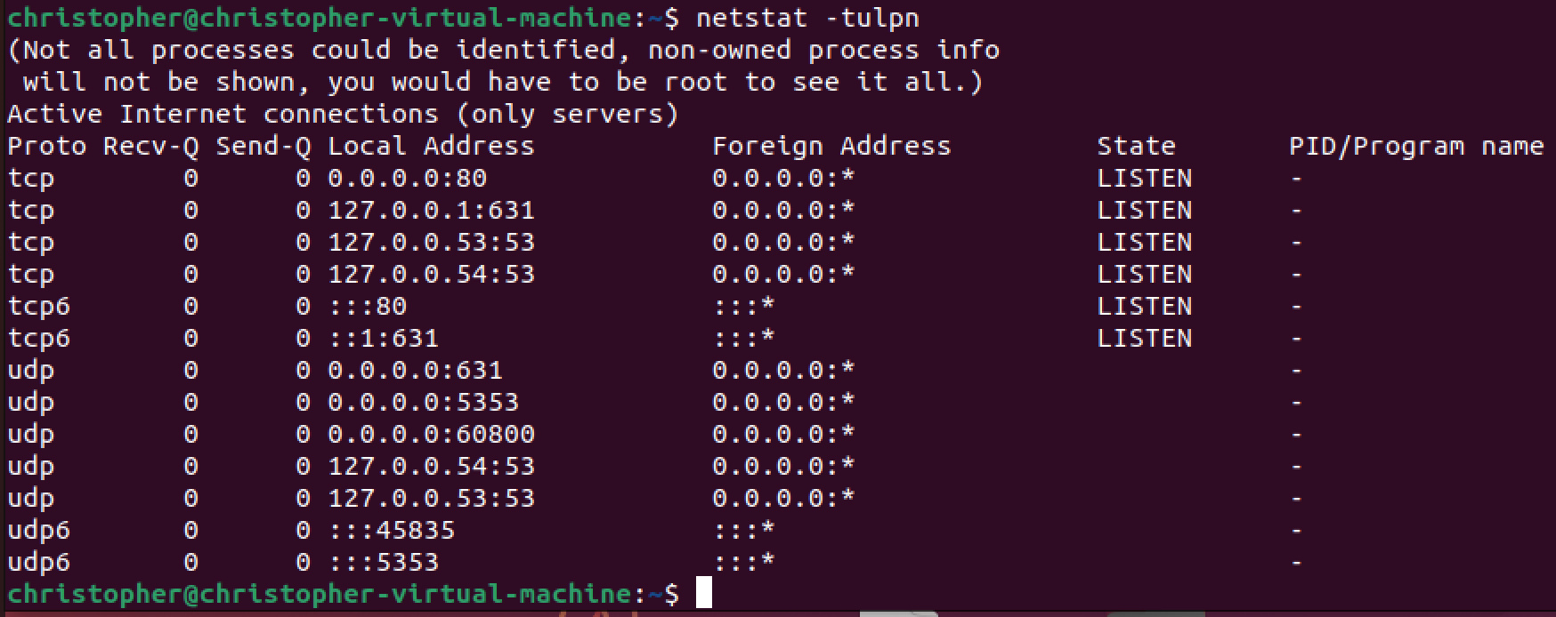

***Make directory***

mkdir; creates a directory



***Check present working directory***

pwd; checks the current working directory



***Remove files and directory***

rm filename ; removes a file

rm -r directory_name; removes a directory

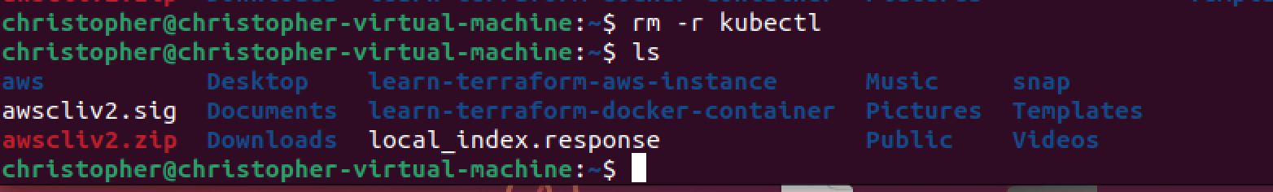

***To check uptime***

uptime; to check uptime of the server.



***Copy file content***

cp {filename1} {filename2}; copies the content of one file to another



***Displays content of file***

cat {file_name}; displays content of {file_name}

***Create a new file***

touch {file_name}; creates a new file



File {filename}; shows the type of document



***Removes files or directory***

rm -I {file_name}; ask for permission before removing a file

rm -rf {file_name}; forcefully removes a file or directory

rm {file_name}; removes only a file, not the file_name.

***More***

more is a filter for paging through text one screenful at a time. This version is especially primitive. Users should realize that less (1) provides more(1) emulation plus extensive enhancements.

head {file_name}; shows the first 10 lines in the file.

tail {file_name}; shows the last 10 lines in the file.

***Displays active users***

id; displays active users



***Shows system logins***

last; shows lists of all active system logins

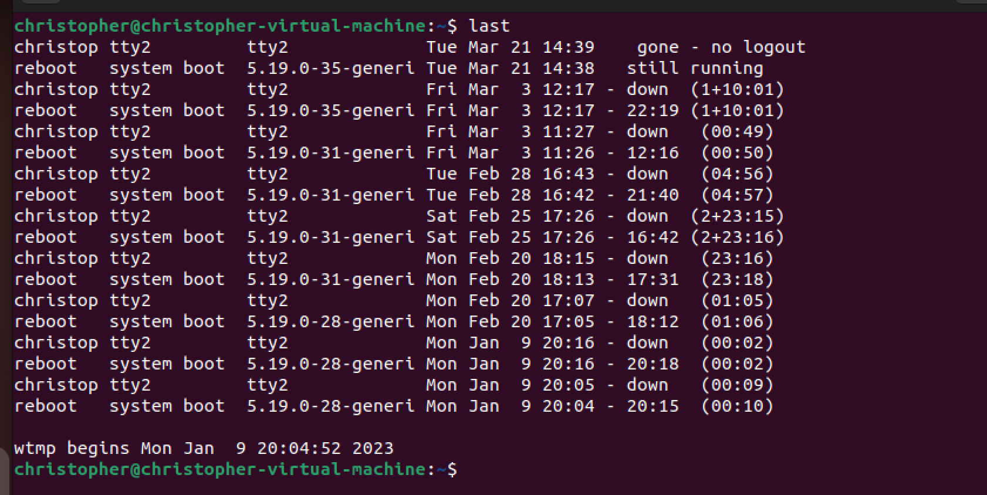

***Current logon***

who; shows who is currently logged in.

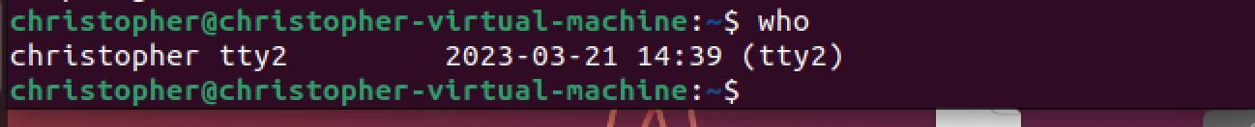

***Add new group***

groupadd {group_name}; adds a new group.



***Add a new user***

adduser {user_name}; creates a new user.



***Delete user***

userdel {user_name}; deletes an active user.



***Modify user***

usermod {user_name}; modifies an active user.

***Change directory group***

chgrp {group_name} {directory_name}; changes the directory group.

***Install package manager***

sudo apt install {package_manager}; installs package manager.

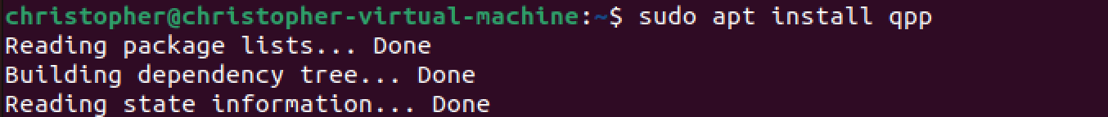

**Terminate a Linux process**

Kill {PID}; Kills a Linux process under a given ID.

***Terminate all processes***

Kill all {process_name}; Terminates all processes with the labelled ID

***Resume stopped jobs***

bg; list and resume stopped jobs in the background

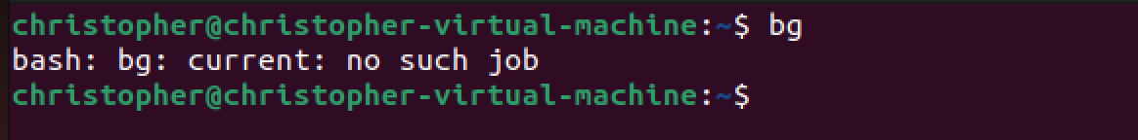

***Resume recently suspended jobs***

fg; brings up the most recently suspended jobs to the foreground.

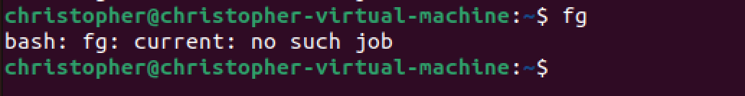

***Shows kernel info***

Uname -a; displays kernel release info



***Display current date***

date; shows current time.



***Displays IP address***

hostname -I; shows IP address



***List IP address***

Ip add show; list all IP address and network interfaces

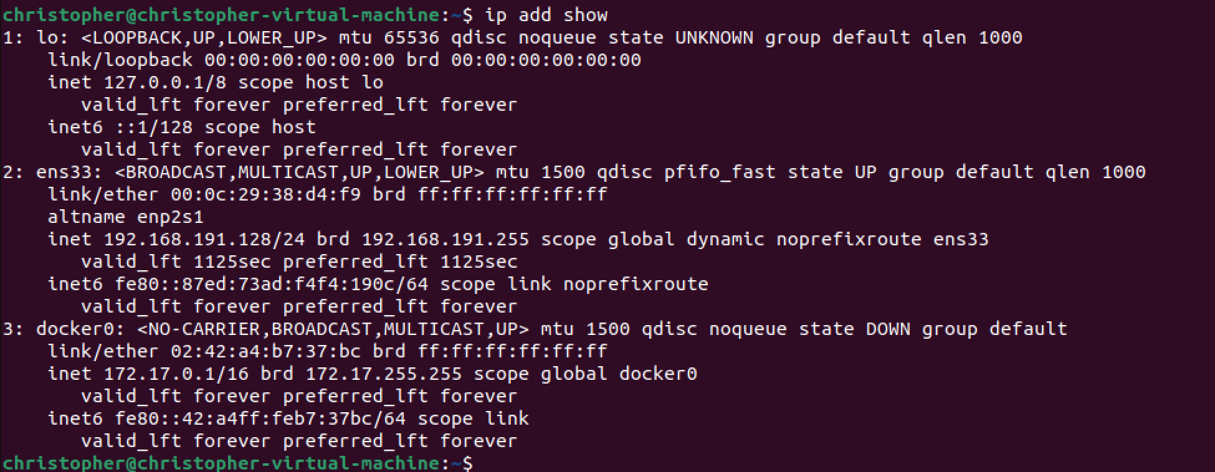

***Add IP address to interface.***

ip address add {IP_address}; assigns IP address to interface etho

***Shutdown***

Shutdown {hh:mm}; schedules shutdown

Shutdown now; immediate shutdown

***DISKS***

df -h; shows free and used space on mounted system

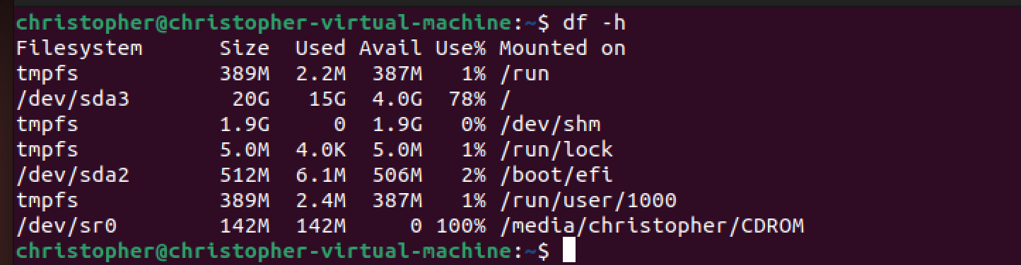

df -ah; shows disk usage for all files and directory.

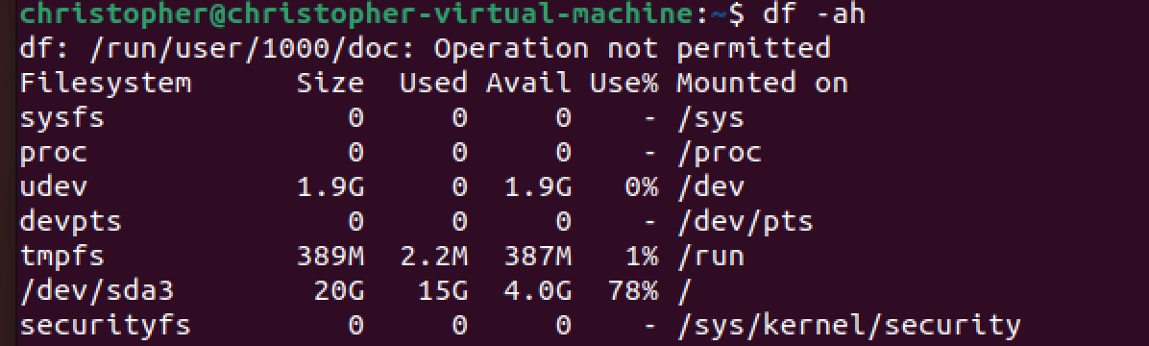

***SSH***

ssh user@host; connects to host as user

ssh -p {port} user@host; connect to host using a specific port number

***File ownership***

Chmod 777 {file_name}; assigns read, write and execute permissions to everyone

Chmod 755 {file_name}; assigns read, write, and execute to owners, read and execute to group and others.

Chmod 766 {file_name}; assigns full ownership to owner, read and right permission to group and others.

Chmod 600 {file_name}; full permission to owner, no access to group and others.

Chown {user_name}:{group} {file_name}; changes the owner and group membership of a file.

***DNS information***

Dig; shows dns information about a domain

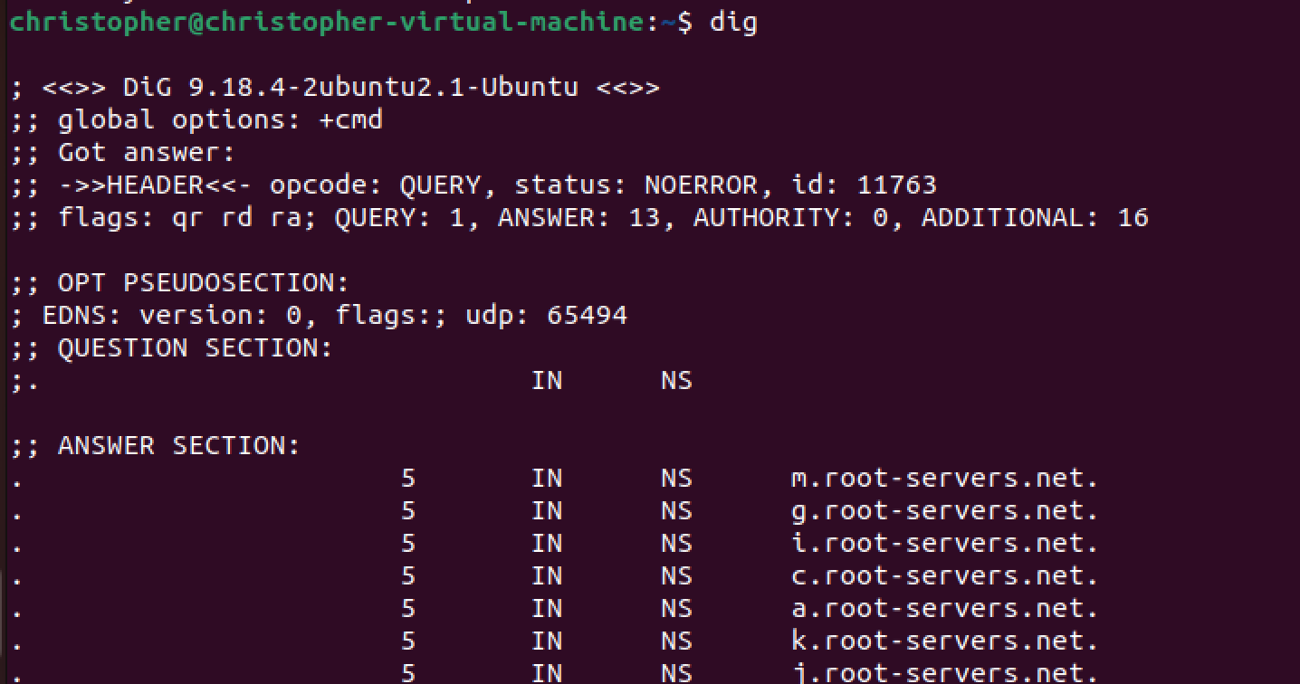

***NSLOOKUP***

nslookup {domain_name}; displays info about internet domain.

***Download file from internet***

wget {filename/web address}; downloads the file or the document from webpage

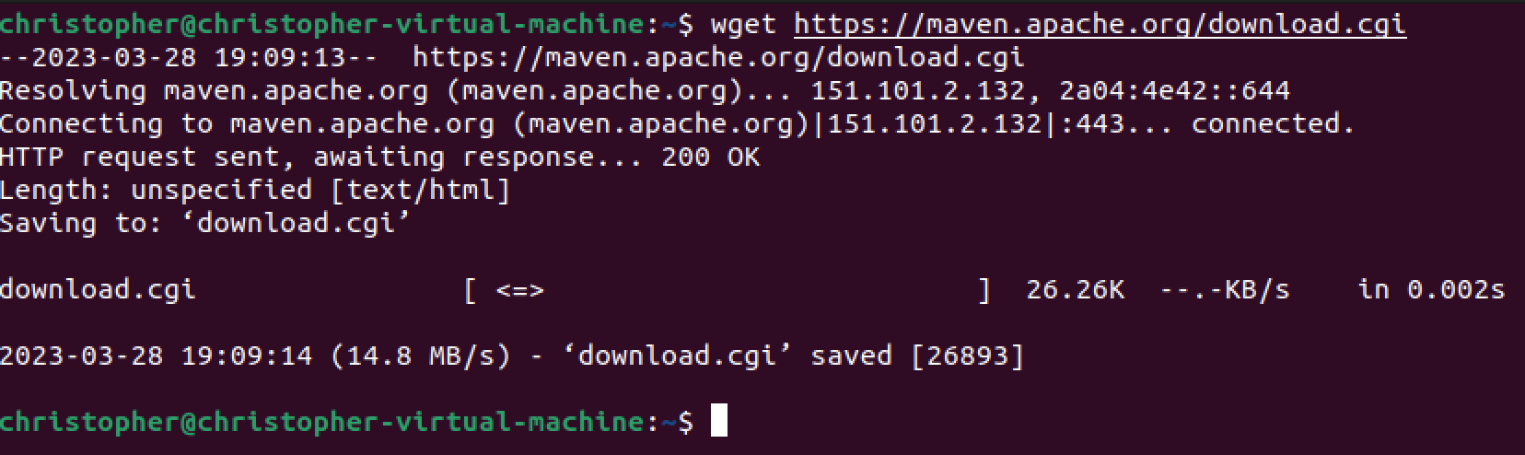

***Remote file save***

Curl -o {file_name}; saves a remote file to your system

***Lock account***

Usermod -L {account_name}; locks an account.

***Admin user add.***

sudo useradd -m {user_name}; adds users as admin

***Set password***

Sudo password {user_name}; sets user password.

***Query system***

Journalctl; queries the system

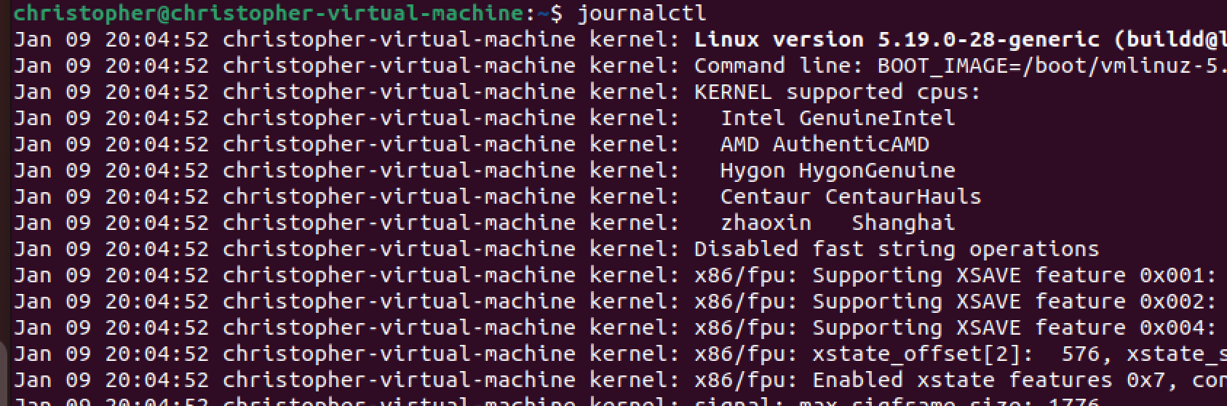

***SYSTEMCTL***

Controls the systemd system and service manager

Manage service

Service {service_name} status

Systemctl status {service_name}

Systemctl status httpd.service; checks status of httpd service

Systemctl start httpd. service; starts httpd service

Systemctl restart httpd. service; restarts httpd service

Systemctl status apache2; checks status of apache service

***Search files***

Ps aux | grep {service_name}; Searches for a pattern in each file.

***Disk***

Mount; Checking existing mount

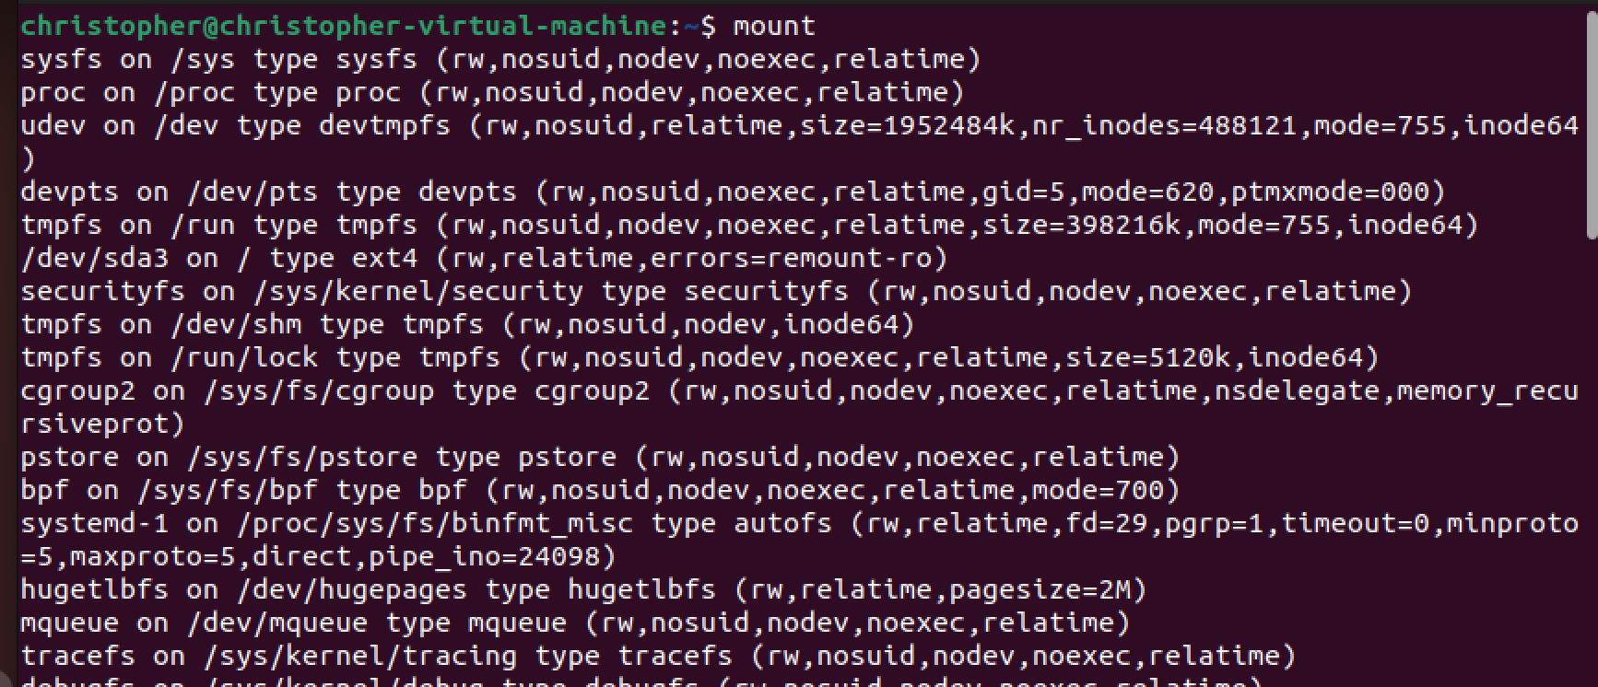

Ls/mnt